Foreword
In January of this year I spent two weeks in Sierra Leone. Calling on a number of Irish missionary schools and projects, I was very conscious that I was meeting the last few of a magnificent Irish involvement in Sierra Leone. Beginning in the 1850’s, they contributed to improved health facilities and education provision in Sierra Leone. Sister Teresa McKeon in Koidu, sixty four years in Sierra Leone, Mary Sweeney in Makeni and our own late patron, Hilary Lyons to name but a few, have made huge contributions to Sierra Leone and have raised the profile of Ireland among its people. Truly we will not see their like again.
And that is the challenge for the Irish Embassy in Freetown and also for SLIP, maintaining a distinctive Irish identity and making a difference to the ordinary people on the ground. The Irish Embassy, together with DIFiD and the World Bank, is doing great work with the Ministry of Education in developing and supporting a national education policy. But we also need to maintain the Irish identity in Sierra Leone.
I have been writing the introductions for the annual SLIP report for the past eight years. Looking back over them, I note that optimism and pessimism seem to change places almost annually. Last year the peaceful change of government and the new government’s apparent energy and sense of purpose gave rise to genuine optimism that Sierra Leone was at last about to turn the corner.
Today that corner is some distance away. The APC’s stated intention to make the country ungovernable coupled with the present government’s perceived distance from the ordinary people has given rise to greater political polarisation in the country. The recent disturbances in Makeni, where a seemingly routine administrative decision, was interpreted as a political affront and resulted in serious rioting causing several deaths, was the latest manifestation of the uneasiness in the country. An unstable currency, losing 15% of its value in the first seven months of this year and the increase in the cost of fuels, makes a difficult life intolerable.
In the post Covid World countries will be pre-occupied with matters much closer to home. Germany has already quit Sierra Leone and Liberia. Unless Sierra Leoneans stop voting for tribe and region and put honesty and competence first, other countries may well follow suit.
Joe Manning (Honorary Consul)

Our identity – who we are
- Sierra Leoneans living in Ireland.
- Irish people who have lived and worked in Sierra Leone – missionaries, teachers, public servants, volunteers, medical personnel, staff of NGO’s and development agencies.
- Irish people who have an interest in Sierra Leone.
- Civil society actors in Ireland.
- Media personnel who have visited Sierra Leone.
- Students who have visited Sierra Leone on exchange projects or who have volunteered to help certain projects.
Our Mission – what we do
Advocacy
- We keep issues affecting Sierra Leone to the forefront in Ireland with Government agencies and business people.
- We engage with Irish Aid about development issues in Sierra Leone.
- We advocate on behalf of Sierra Leonean asylum seekers and those living in direct provision.
Sharing knowledge and experience
- We give information to people wishing to travel to Sierra Leone – tourists, aid workers, journalists, volunteers.
- We organise public events for the benefit of the people of Sierra Leone.
- We are a point of contact for the media.
- We give information to Sierra Leoneans in direct provision.
Networking
- We work with other agencies to strengthen our voice.
- We highlight relevant issues on the SLIP website, Facebook and Twitter.
Projects
- We support projects in Sierra Leone.

Introduction
The annual Report for 2019 to 2020 relates to the activities of the Sierra Leone Ireland Partnership from the Independence Celebration in June 2019 until June 2020. The committee meet monthly and continue their work and research in the area of education, particularly teacher training, school governance and issues affecting girls and women. They endeavour to increase Irish Government awareness of issues in Sierra Leone or affecting Sierra Leoneans in Ireland. They advocate on behalf of Sierra Leone asylum seekers. They meet Irish Aid and maintain contact with the Irish Embassy in Freetown.

SLIP committee
Elizabeth Smith (Chairperson), Martin Rowan (Hon. Secretary), Liam McGlynn, Ibrahim Bah (Hon. Treasurer), Jim Owens (PRO), Geraldine Horgan (Webmaster), Joe Manning (Hon. Consul), Joseph Bockaire, Sean Farren, Eddie Finnegan, Frank Roden, Tony Robinson.
The committee meet monthly and their work is voluntary.
We thank the members of the committee who have devoted their time and effort in furthering the interests of Sierra Leone and her people.
We are grateful to all the members of SLIP who have supported SLIP events throughout the year and for their financial support through membership and donations.

Review of Activities 2019 --- 2020
Sierra Leone Independence Day Celebration June 2019
With due respect to the two great religious celebrations of Easter and Ramadan our Independence celebration got pushed to a mid-Summer evening of 21st June, in Wynn’s Hotel, Dublin.
It was an evening where we had a number of exciting and quite contrasting presentations.
Sr. Hilary Lyons MSHR gave a heartfelt review of her experiences in Sierra Leone from her first ‘tour of service’ beginning in 1953 after a 10 day ship journey. Her commitment to working in Sierra Leone continued for another amazing 42 years. In her presentation she was very honest about all she learned during her years in Sierra Leone and also all the unlearning she had to do. As the years rolled by, her appreciation and admiration of the people she served with her healthcare skills grew ever deeper. She challenged herself on the best ways to address the many pressing health needs, moving from the hospital based care to the need to develop better services in the community. She became more aware of the importance and urgency for greater preventative health care practises in order to reduce the need for curative medicine. Sr. Hilary supported and urged people to always seek ways to improve health practices in a culturally acceptable manner. Part of the community programme was further training with some village based midwives. As one can expect Hilary declared ‘I came to love these older women for their strength, their wisdom and their humour’. Hilary never hesitated to challenge others especially those in authority in demanding the best service possible for people in greatest need. As always she shared graciously, and her wisdom and wit drawn from her 95 years of generous living was very well received by all present.
Ms Bernie Moran was equally delighted and enthusiastic about her experience of Sierra Leone. Bernie is the CEO of the Credit union branch in Roscommon. She is also active in the Irish League of Credit Union Foundation (ILCU).The foundation aims to alleviate poverty in developing countries by supporting credit unions and their representative bodies through the provision of financial and technical assistance. Bernie and two colleagues visited Sierra Leone for two weeks in a structure coaching programme, to assist and build bonds with some local Credit Unions in Sierra Leone. While her stay there was short she interacted with many people both in Freetown and in the Kailihun area. She found the 8 hour trip to Kailiahun a significant learning experience. It was her first trip to Africa and she was in awe of the people and how they coped with their many challenges. There are over 28 credit Union offices in Sierra Leone and the numbers are growing. It is clear that the support they provide is opening up opportunities for many communities in Sierra Leone.
Austin Kennan, the recently appointed Concern Director in Sierra Leone, also spoke to the gathering. He has been a supportive member of SLIP over the years and promised to continue these links into the future.
Mr Ciaran McGoey spoke briefly of the needs of Yengema Secondary School and a forthcoming fundraising concert with Liam Lawton.
The success of the evening depends on the help of many people. It is unfair to name any particular member of the SLIP committee but each added to the success and enjoyment of the evening.
As always the evening provided a great opportunity for people to meet and catch up on the news and developments in the ever deepening links between Ireland and Sierra Leone.
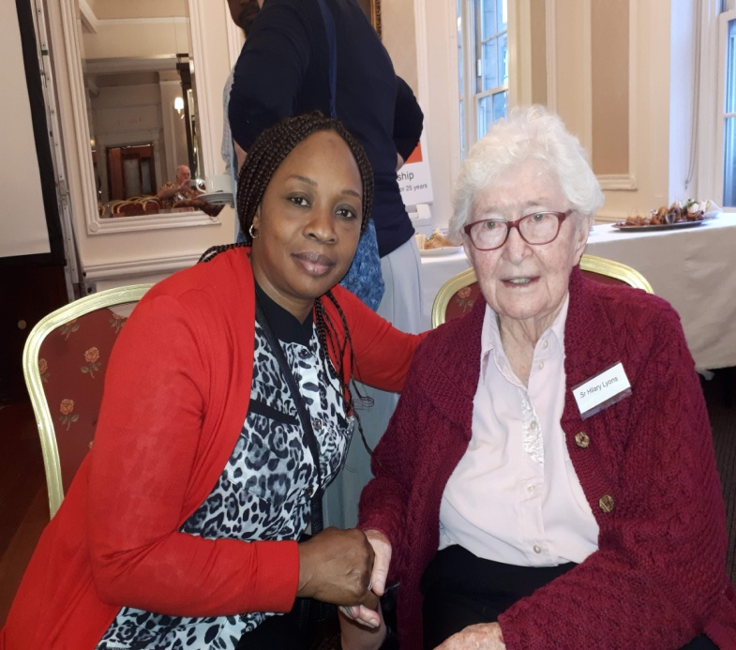
Sr. Hilary Lyons and Binto Diolla
Annual General Meeting
The Annual General Meeting was held in Belgrave Square, Rathmines on 19th October 2019.
The following officers were elected/re-elected:
Chairperson: Elizabeth Smith
Treasurer: Ibrahim Bah
Secretary: Martin Rowan
PRO: Jim Owens
The Report and accounts for 2018-2019 were presented and accepted.
It was agreed that at each Committee meeting a section of the Charities Governance Code would be read and discussed in order to fulfil our obligation to adhere to the Code.

SLIP Reflection Day
The AGM was followed by a SLIP Reflection Day which was facilitated by Kai Matturi. The purpose of the activity was to review the work of SLIP and plan for it’s long term future. The meeting began with the identification of some of the achievements of SLIP over the years. This led to reflection under the following headings:
- Who SLIP is?
- What Slip does?
- How SLIP operates?
- With whom does SLIP relate?
The final section of the meeting discussed the Future for SLIP and endeavoured to answer the questions:
- Where are we now?
- What is driving change?
- What are the strategic issues affecting SLIP?
The day was very beneficial and focussed the thoughts of the committee and members of Slip on what needs to be done to assist the development of Sierra Leone.

Strengthening Education in Sierra Leone Seminar
SLIP in partnership with Maynooth University Department of International Development hosted the seminar which was held on the 5th March 2020 in the Renehan Hall, Maynooth University. The title of the seminar was “Building an Equal and Inclusive Education for Girls and Young Women in Sierra Leone”.
The first session dealt with the “Role of State and Faith-based Institutions in Education in Sierra Leone”. The session was chaired by Dr. Sean Farren, former Northern Ireland Minister for Further Higher Education. The Introduction and Address was delivered by Dr. Staneala Beckley, Chair of Sierra Leone Teaching Service Commission. The title was “Capacity issues and possibilities for delivery of the GOSL plans for education, in particular the pivotal role of teachers and the teaching profession”. She described the plans that the new Government of Sierra Leone have for the development of education. One of the issues was the lack of qualified teachers, particularly in rural areas and the need for more CPD courses being available. Dr. Beckley also outlined how schools and in particular girls were affected by the various problems that have occurred in Sierra Leone, such as Civil war and Ebola. In many cases this led to the closure of schools. There are also cultural problems where young girls are forced into marriage and do not finish Secondary School.
This was followed by The Most Reverend Dr. Henry Aruna, Bishop of Kenema Diocese, Sierra Leone whose talk was titled “Opportunities and Challenges in exercising responsibility for the Catholic School network in context of Government’s new emphasis on education, in particular education of women and girls.”. He emphasised the need of quality school education as a high percentage of the population is illiterate. The percentage of the female population in this situation is higher than that of males.
There followed a question and answer session which was interesting and informative.
The second session began with former Minister for Justice and Equality, Norah Owen as chair and was delivered by Ms. Carol Hannon, Department of Foreign Affairs and Trade. The title of her address was “Policy Considerations and Priorities of Irish Aid in Sierra Leone.
This was followed by Posters from NGOs. Irish League of Credit Union Foundation, Sightsavers, Concern, Trocaire, Plan Ireland, Liberia Solidarity Group, Global Schoolroom and Don Bosco Fambul. Each group gave a short presentation of their work.
The day was concluded by the chair of Sierra Leone Ireland Partnership, Ms. Elizabeth Smith.
A follow on from the Seminar was that Ms. Geraldine Horgan from SLIP has set up communication between Dr. Beckley and the Irish Teaching Council with a view to assisting The Sierra Leone Teaching Commission.

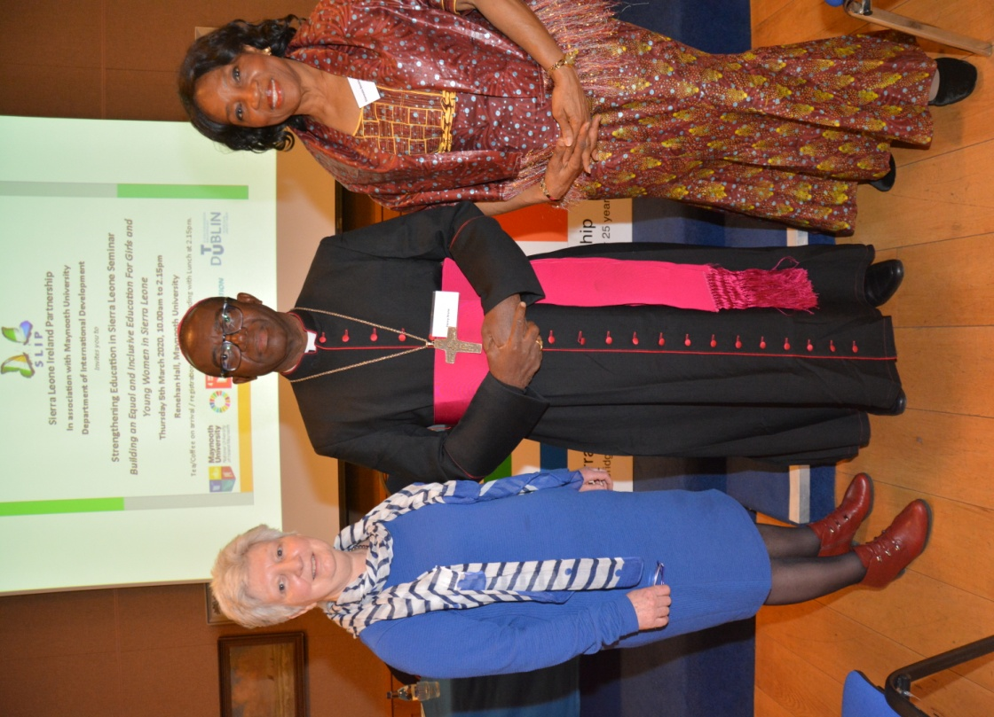
Geraldine Horgan (SLIP), Bishop Henry Aruna and Dr. Staneala Beckley

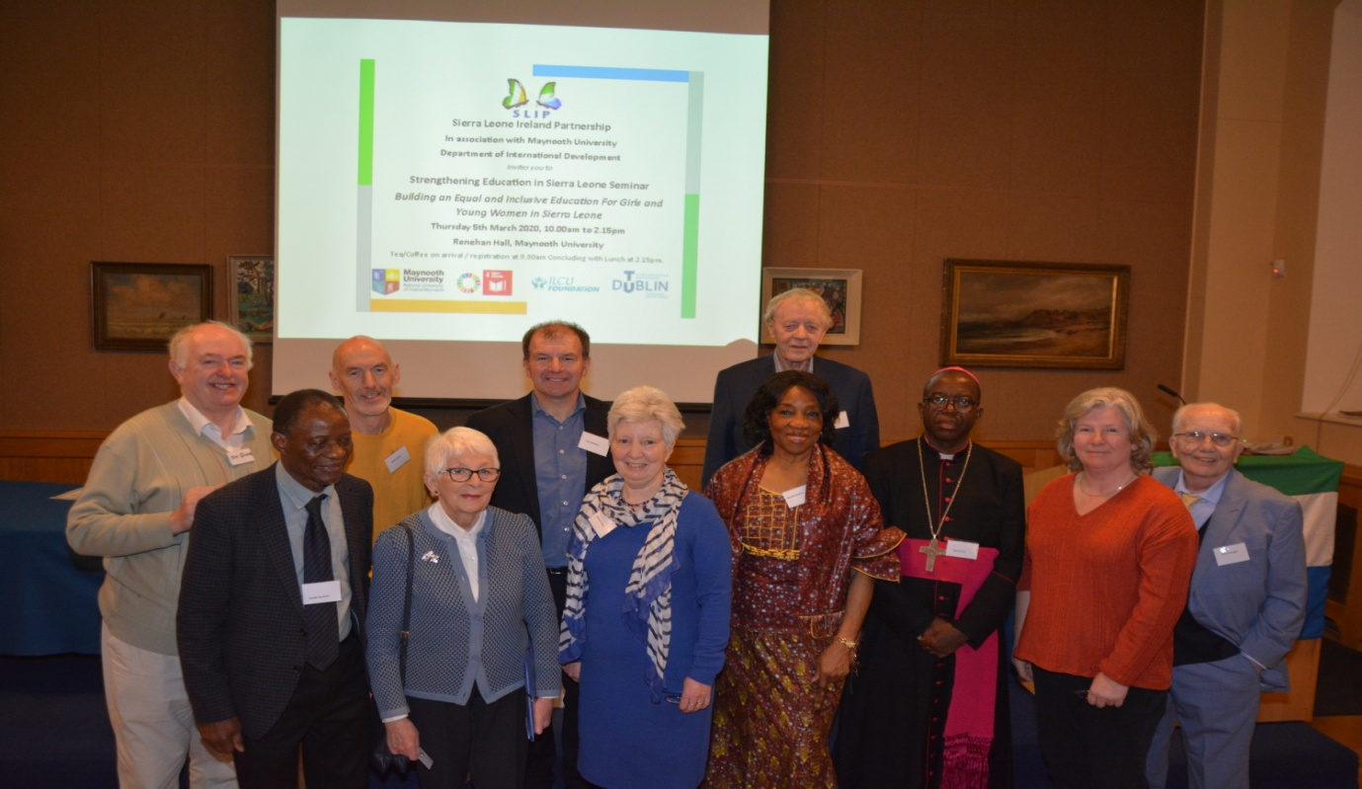
SLIP Committee members with Bishop Aruna and Dr. Beckley

A Historic Gathering in Kimmage Manor
A great and joyful gathering took place in the parish Hall at Kimmage Manor on Friday 6th March 2020, just weeks before the unprecedented ‘Coronavirus lock down’.
The previous day there was a well-run and effective conference in Maynooth University. The Kimmage Gathering, also organised by SLIP members, was a more relaxed but no less significant opportunity to share stories and views, pray together and enjoy good Spiritan hospitality.
It was an important opportunity to converse with the two guests who travelled from Sierra Leone, Dr Stanela Beckley and Bishop Henry Aruna.
People travelled from many parts of Ireland from Cork to Derry. As well as many Spiritan missionaries there were some Missionary Sisters of the Holy Rosary and also many lay people who had connections and interest in Sierra Leone. After welcome and introductions both guests spoke a little about themselves and some of the tasks they face in their respective roles. Some of the people present shared their stories of Sierra Leone and answered questions. Dr Stanela give an outline of the many challenges facing schooling in Sierra Leone with particular emphasis on the need for greater numbers of qualified teachers. The problem is more acute in rural schools especially those a good distance from urban centres. Bishop Aruna spoke about the demands on the diocese to support the many schools under Catholic patronage. Sometimes they have the responsibility without the authority. There are many government demands and regulations but the financial support is often limited and obtaining recognition and support is quite bureaucratic.
Fr Michael Fillie was among the many contributors who spoke, sharing his passion about the needs and dreams of Sierra Leone.
After the conversations the group took some time for prayer and reflection. Sr Bridget Lacey MSHR read a gospel passage from Luke 4:16-22. It gives the blueprint for ministry; sharing the good news with poor people, liberty to those in captivity or downtrodden and healing to those bearing illnesses or disability. In the group present people have been and are living out the challenges of this reading.
After the prayer Mr Ciaran McGoey and the never-tiring former teachers of Yengema Secondary School presented a cheque to Bishop Aruna for the further development of the YSS. It was the result of a great fundraising concert in Longford Cathedral.
Martin Rowan gave a warm vote of thanks to the two guests and to all the people who attended and participated in the afternoon event.
An article on the event with an interview with Bishop Henry was prepared by journalist Ms Rosie McGrath and published in the Irish Catholic.
Many people spoke of their delight in meeting the two guests and were most thankful to the SLIP committee for organising a memorable afternoon of sharing and solidarity.

There have been connections between Ireland and Sierra Leone for over 150 years. Irish missionaries and volunteers have done incredible work in education and health. Now, sadly a number of these tireless workers are finishing their time in Sierra Leone but we must not lose the connection between the two countries. The SLIP Seminar indicated how a number of Irish groups are still working in Sierra Leone. SLIP is currently playing a role is assisting those Sierra Leoneans who live in direct provision in Ireland. The advocacy role of SLIP is vital to these refugees.

Sr. Hilary Lyons R.I.P.
Sr Hilary Lyons was the President of the Sierra Leone Ireland Partnership from 2001 ‘til her death in January. This role was one of many chapters in her nearly seventy years of physical and intellectual engagement with Sierra Leone. The nature of that engagement preoccupied her during her forty years in hospital surgery and public health there, and she stayed with the questions it raised to the very end of her life. She was devoted to decolonising the framework of Catholic Missionary and medical intervention.
For us in SLIP she was an adored authority figure who graced our assemblies and lobbying events with her wisdom and humour. The aura that accompanied her opened many doors for SLIP's efforts to deepen public policy links between Ireland and Sierra Leone.
She interrogated the missionary and medical models in which she was trained. Though “we did not ask" was a regret she often voiced, her own ear was finely tuned to the faith and practice of the Mende people amongst whom she worked. She respected that faith deeply. She was a welcome confidánt at its inner circles and she never stopped exploring the significance of its clashes with her own mindset and medical priorities. She read deeply and widely. She loved the Wisdom literature, creation theology, and the work of the Mayo theologians, especially scripture scholar Seán Freyne.
Through her ninety six years she modelled the kind of reflective and affectionate solidarity with Sierra Leone which SLIP works to inspire and sustain. She left us with work to do on ourselves and on our mission.
Martin Rowan

